TOWN OF MONTVILLE
WATER POLLUTION CONTROL AUTHORITY
_________________

Request for Proposal (RFP)- Pump Station Roof Replacement
July 8, 2022
RFP ID: 2023-1
Question submission deadline: July 22, 2022
Bid Submission deadline: July 29, 2022 2 p.m.

Introduction:
The Town of Montville WPCA is seeking proposals to remove and replace roofs, siding and trim at two sewer pump stations located within the Town of Montville. (See attached images)

Job Description:
Roof Replacement
- Remove existing shingles from roof
- Replace any rotten or damaged sheathing
- Provide new drip edge trim
- Provide new flashing
- Provide Ice and water shield on all roof sections
- Provide GAF High Definition asphalt shingles (weathered wood)
- Install new ridge vent
- Clean up all shingle debris and remove off site

Siding Replacement
- Remove all soffit rake and facia trim
- Replace all exterior trim with new PVC
- Provide vent strip in PVC soffits
- Remove and plywood gable vent
- Remove existing wood siding
- Replace all damaged or rotten plywood
- Install fiber cement prefinished clapboard style siding on gables
- Utilize stainless fasteners
- Remove all debris off site

TOWN OF MONTVILLE
WATER POLLUTION CONTROL AUTHORITY
_________________
“Chesterfield” Pump station
575 Chesterfield Rd
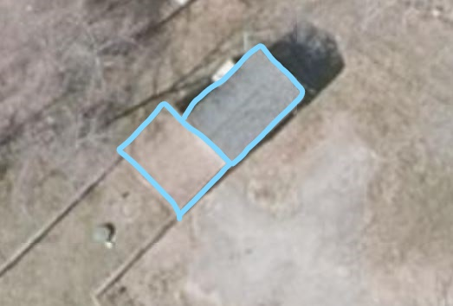

“Holly Hill” pump station
2549 Norwich- New London TPKE
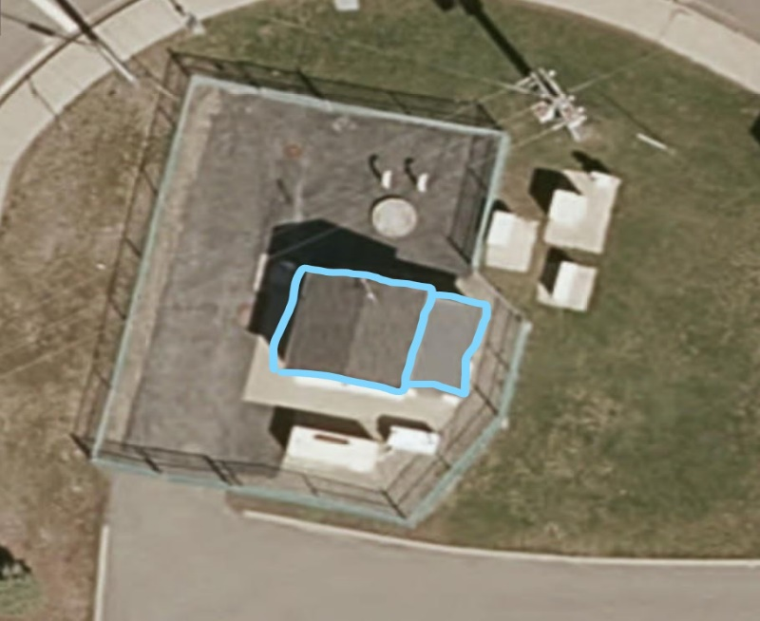

TOWN OF MONTVILLE
WATER POLLUTION CONTROL AUTHORITY
_________________

For Project questions please contact:
Kevin Loiler, Maintenance Mechanic
Montville WPCF, 83 Pink Row, Uncasville CT 06382
Phone 860-848-3830 X653
Cell# 860-625-3995
Email: KLOILER@MONTVILLE-CT.ORG

TOWN OF MONTVILLE
WATER POLLUTION CONTROL AUTHORITY
_________________
Bid Disclosure
The Town of Montville reserves the right to reject any or all bids and waive any informalities or irregularities in the bid procedure or bids.
The Town may hold the RFPs for a period not to exceed sixty (60) days from the date of the bid opening to review the bids and investigate the bidders’ qualifications prior to awarding the contract.
All responders are advised the Town of Montville has enacted through resolutions the following special conditions concerning Town bids and purchases. A standard Town contract is available upon request.
1. For all Town purchases of goods and services not utilizing State or Federal funds, any Town
bidder that has submitted a bid not more than 15% (fifteen percent) higher than the low bid may
be awarded the project provided such Town based bidder agrees to accept the award of the bid at
the amount of the low bid. If more than one Town based bidder has submitted bids not more than
15% (fifteen percent) higher than the low bid, and have agreed to accept the award of the low bid,
the lowest responsible bidder shall be the one of such Town based bidders that submitted the
lowest bid. That within the bidding process that all businesses claiming to be Montville
businesses, provide the Finance Department (Assessor’s Section) with sufficient documentation
to prove that they are in compliance with property tax assessments, including motor vehicle tax
assessments.
2. Seller agrees that as a condition of his sale of goods and/or services to the Town of Montville,
the Town of Montville will be authorized to deduct from the proceeds due Seller an amount not to
exceed 25% of the total amount due Seller. Said amount is to be applied against any unpaid and
overdue taxes, assessments, fees, or other charges levied by the town of Montville or any agency
thereof against the Seller. The Seller further agrees that Seller shall insure that Seller has the right
to withhold an amount not to exceed 25% from each subcontractor working for the Seller, and
providing goods and/or services to the Town of Montville, and to remit such withheld money to
the Town in full or partial satisfaction of any unpaid and overdue taxes, assessments, fees, or
other charges levied by the Town of Montville or any agency thereof against such subcontractor.
The undersigned has examined the basic requirements of the RFP and hereby offers to provide
the Town of Montville Water Pollution Control Authority Parts, Labor & Installation by the specs
in this RFP for the Total Sum of $________________________________
Date__________________________________________________
Signature______________________________________________________________
(Print) Name _________________________________ Title____________________
Firm_______ _____________________________________________________
Address __________ _______________________________________________

